Preview of bank accounts entity before normalization:

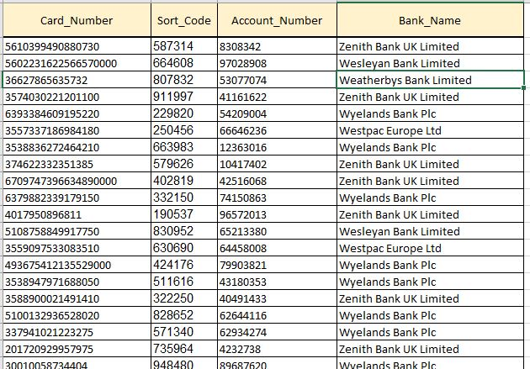

1NF

Bank_accout_ID is primary key.

2NF

Attribute card_number will be separate in different entity.

3NF

Entity is already in 2NF and there is no transitive attributes.

Preview of table after normalization:

